Friday, January 6, 2017
Through a generous donation by photographer Stephanie Marty and her family, patients and families at our inpatient care centers will get to enjoy a recently published book featuring scores of beautiful Jacksonville images.
Surrounded by family and Community Hospice employees, Marty donated 100 copies of "Jacksonville, Florida, a photographic tour," her self-published book, at the Anne and Donald McGraw Center for Caring. That's where her father-in-law, Richard E. Marty, died on Easter Sunday in 2012 after a long battle with cancer.
Marty said the book is her family's way of giving back to Community Hospice. When Richard Marty was a patient at McGraw, Community Hospice nurses gave Marty's mother-in-law, Betty Marty, a copy of Michael Holmes's "Crossing the Creek," a guide to provide dying people and their caregivers’ insights about the dying process.
Marty's donation makes it possible to place her books in all 91 inpatient center rooms, from Fernandina Beach to St. Augustine, where patients and families are sure to enjoy more than 85 pages of unique and vibrant color photographs.
Dietician Kerry Dew, Respiratory Therapist Supervisor Tammy Esposito, Primary RN Mary Newman, Clinical Resource Nurse Eileen Reeve and Director of Major and Planned Giving Donna Morrow were on hand to greet the family and receive the donation.
"This book is a great conversation starter," said Reeve as she turned each colorful page.
Marty, who grew up in Jacksonville and graduated from the University of North Florida, worked in accounting and human resources before switching careers to become a photographer. She undertook the project in early 2015 and spent three months capturing the images that fill the book's pages.
"I completed this project not for business but for my family," Marty said. "I just want people to enjoy it."
​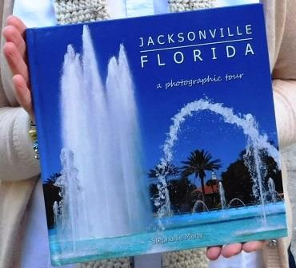
​Stephanie Marty's book: "Jacksonville, Florida: a photographic tour" with Friendship Fountain on the cover
Marty has a history of using her talents to give back to the community. Many longtime Jacksonville residents know her work photographing events organized by the Otis Smith Kids Foundation, including the Florida Sports Awards, the Sea Cows for Kids and the Big Cats for Kids. While Marty no longer photographs for clients, photography remains an important part of her life.

The book is available for sale at San Marco Books and More and Barnes & Noble, or through Amazon. There's a link at stephanniemarty.com.

​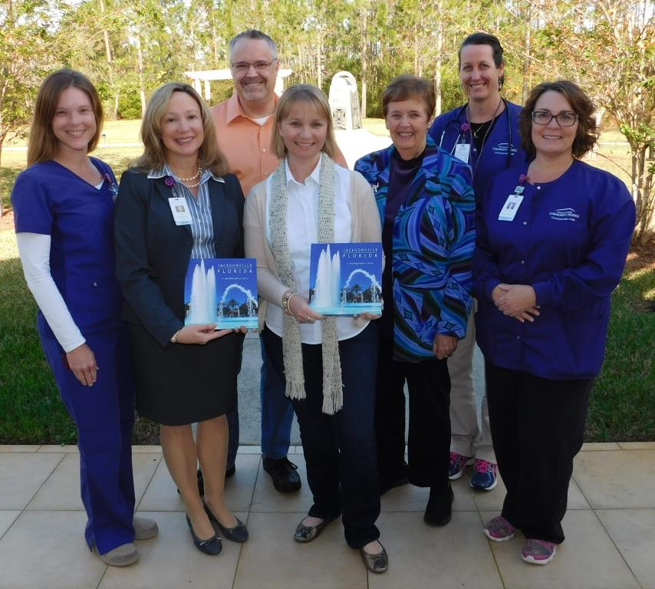
​Through a generous donation by photographer Stephanie Marty and her family, Community Hospice patients and families will get to enjoy a recently published book containing scores of beautiful images of Jacksonville. (Pictured from left to right) Kerry Dew, Eileen Reeve, Steve Marty, Stephanie Marty, Betty Marty, Mary Newman and Tammy Esposito

